The Gulf countries want to reshape the Middle East in their image

Stability and development is a tempting formula, but it has been tried before

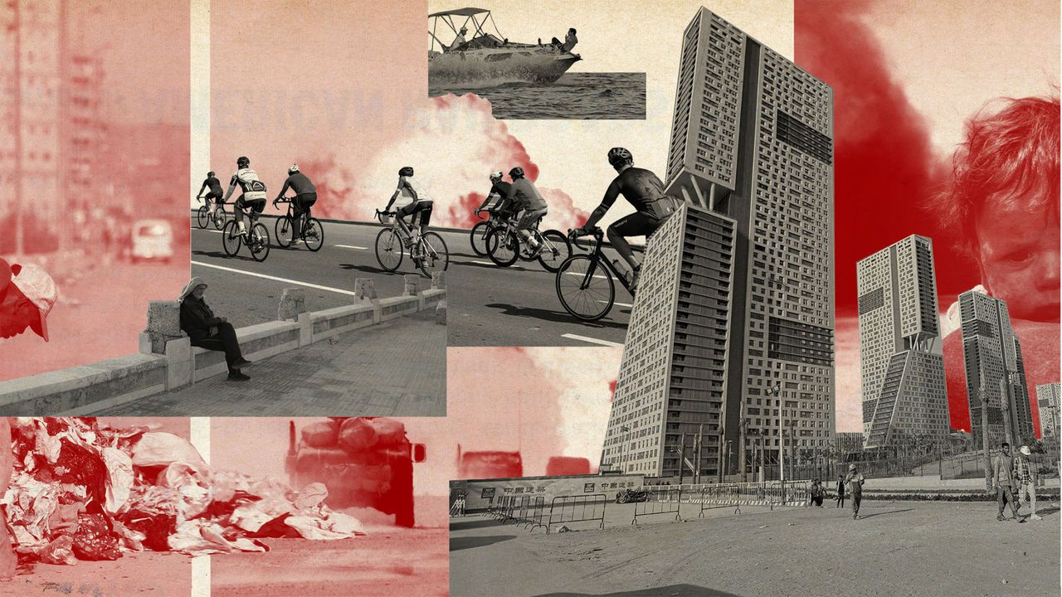

image: anthony gerace/getty images

Sep 7th 2023 | DUBAI

“总结： 过去二十年以来，以色列和巴勒斯坦的冲突相对较为缓和，但这种状况不太可能永远持续下去。在圣地发生严重冲突可能动摇阿拉伯国家与以色列的协议。利比亚、叙利亚和也门的暴力冲突有所减弱，但潜在的争端仍未解决。阿萨德上个月在动荡不安的南部省份斯韦达面临了一波抗议浪潮。而沙特阿拉伯和阿联酋，尽管是新中东的主要支持者，但在外交政策和经济问题上经常存在分歧。此外，海湾国家与中国的合作也存在风险。最后，曾有人认为通过贸易促进中东地区的和平是可行的，但目前仍面临许多挑战。”

Until last month the brics, a diplomatic club which comprises Brazil, Russia, India, China and South Africa, had members from every corner of the developing world except the Middle East. No longer: of the six countries invited to join the bloc at its annual summit on August 22nd, four—Egypt, Iran, Saudi Arabia and the United Arab Emirates (uae)—are from the region. If they all accept, the Middle East will account for more than a third of the expanded bloc’s members.

直到上个月，金砖国家（包括巴西、俄罗斯、印度、中国和南非）是一个由发展中国家各个角落的成员组成的外交俱乐部，而中东地区一直没有加入。然而，现在情况有所改变：在8月22日的年度峰会上，有六个国家受邀加入该俱乐部，其中四个（埃及、伊朗、沙特阿拉伯和阿拉伯联合酋长国）来自中东地区。如果他们都接受邀请，中东地区将占到扩大后俱乐部成员的三分之一以上。

The invitations are one sign among many that the Middle East is changing. Wealthy Gulf states are trying to establish themselves as non-aligned middle powers. Saudi Arabia has offered to mediate between Russia and Ukraine. The uae, which will host this year’s global climate summit, cop28, wants to fashion a dual role as both oil exporter and green-energy powerhouse. The six-member Gulf Co-operation Council (gcc) is one of the world’s economic hotspots, drawing the talented and the ultra-rich from east and west and deploying vast pools of capital abroad.

这些邀请是中东地区正在发生变革的众多迹象之一。富裕的海湾国家正试图确立自己作为非附属的中等强国。沙特阿拉伯已提出调解俄罗斯和乌克兰之间的冲突。阿拉伯联合酋长国（UAE）将主办今年的全球气候峰会COP28，并希望发挥石油出口国和绿色能源强国的双重角色。六个成员国的海湾合作委员会（GCC）是世界经济的热

Even more striking is the Middle East’s newfound (and relative) calm. A ceasefire has quietened the eight-year war in Yemen. Iran and Saudi Arabia agreed to ease their 40-year feud in March. Qatar has repaired relations with its neighbours. The region has even reconciled with Syria’s murderous dictator, Bashar al-Assad. America, meanwhile, is urging Saudi Arabia to join the Abraham Accords, under which four other Arab countries have established ties with Israel since 2020.

Five years ago Muhammad bin Salman, Saudi Arabia’s crown prince and de facto ruler, offered a hopeful vision of where things might go. “I think that the new Europe is the Middle East,” he said. “The next global renaissance will be in the Middle East.” His comments fit an increasingly popular narrative in the Gulf, that a “new” Middle East will be focused on economics rather than democratisation, Islamisation or other distracting ideologies. Diplomacy will bring stability, which will foster investment and growth that helps everyone move beyond the upheavals of decades past. The Gulf states have long applied this model at home; now they want to export it.

The Middle East has huge potential. First, and most obvious, it is awash with hydrocarbons. It accounts for 36% of world oil production, 46% of oil exports, 22% of natural-gas output and 30% of liquefied natural gas (lng) exports. Those numbers will only rise. The region has vast reserves (52% of the world’s total for oil and 43% for gas) and low production costs. At a time when Western oil majors are skittish about investing, Gulf firms are adding capacity.

Location is important, too: the region connects Europe, Africa and Asia. Some 30% of the world’s shipping containers pass through the Suez canal in Egypt, while 16% of its air cargo flies via airports in the Gulf. Its young population is another asset: 55% of Middle Easterners are under 30, compared with 36% of the population of the oecd, a club mostly of rich countries.

五年前，沙特阿拉伯的王储穆罕默德·本·萨勒曼提出了一个充满希望的愿景，他说：“我认为新的欧洲就是中东。中东将成为下一个全球复兴的地方。”他的言论符合海湾地区日益流行的观点，即“新”的中东将专注于经济发展，而不是民主化、伊斯兰化或其他分散注意力的意识形态。通过外交手段实现稳定，进而促进投资和增长，帮助每个人摆脱过去几十年的动荡。海湾国家长期以来一直在国内应用这种模式，现在他们希望将这种模式推广到其他地区。

中东地区拥有巨大的潜力。首先，也是最显而易见的，该地区拥有丰富的油气资源。中东地区占据了全球36%的石油产量、46%的石油出口、22%的天然气产量和30%的液化天然气（LNG）出口。这些数字还将继续增长。该地区拥有巨大的储量（占全球石油储量的52%和天然气储量的43%），并且生产成本较低。在西方的石油巨头对投资产生疑虑的时候，海湾地区的公司正在增加产能。

地理位置也是重要的因素：该地区连接着欧洲、非洲和亚洲。约30%的全球航运货柜通过埃及的苏伊士运河，而16%的空运货物经由海湾地区的机场运输。该地区年轻的人口也是一项资产：55%的中东人口年龄在30岁以下，而相比之下，oecd（主要由富裕国家组成的俱乐部）的人口中只有36%年龄在30岁以下。

**Monumental misfortune**

Yet the story of the past two decades has been one of conflict and despair. First came America’s ill-fated invasion of Iraq in 2003. The fury of the Arab spring followed, bringing upheaval but not democracy: all the countries affected eventually either reverted to dictatorship or collapsed into civil war. Islamist violence and sectarian strife compounded the region’s woes.

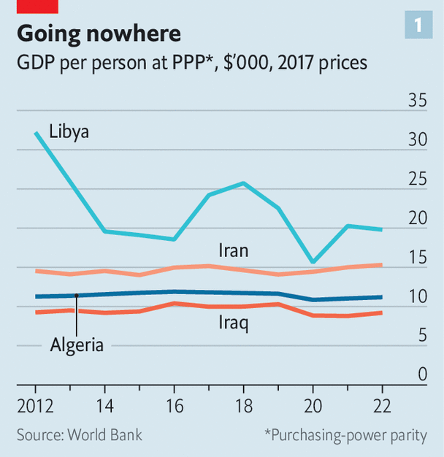

image: the economist

The Middle East accounts for 6% of the world’s population but just 4% of economic output. Strip out a few big oil producers and that figure falls below 2%. In much of the region gdp per person is stagnant or falling (see chart 1). Poverty rates have soared in Egypt and Lebanon, to say nothing of war-torn Sudan, Syria and Yemen.

But three big shifts are under way that could change the place of the Middle East in the world. The first is the growing distance between the Gulf states and America. Three successive presidents have sought to reduce America’s military presence in the Middle East. Joe Biden, the current one, is not trying to impose democracy on the region; he does not even seem too interested in reining in Iran’s nuclear programme. America has other priorities: competition with China, the war in Ukraine, political turmoil at home.

然而，过去二十年的故事充满了冲突和绝望。首先是美国于2003年对伊拉克的不幸入侵。紧随其后的是阿拉伯之春的愤怒，带来了动荡，但却没有带来真正的民主：所有受影响的国家最终要么重归独裁，要么陷入内战。伊斯兰极端主义的暴力和宗派间的冲突进一步加剧了该地区的困境。

中东地区占全球人口的6％，但仅占全球经济产出的4％。剔除掉一些大型石油生产国后，这个比例会降至2％以下。在该地区的大部分地区，人均国内生产总值（GDP）停滞不前或下降（参见图表1）。埃及和黎巴嫩的贫困率飙升，更不用说饱受战争蹂躏的苏丹、叙利亚和也门了。

但是即将发上的三大转变可能会改变中东地区在世界上的地位。首先是海湾国家与美国之间的差距正在逐渐加大。连续三任总统都在寻求如何减少美国在中东地区的军事。现任总统拜登，并没有试图将民主强加于该地区；他甚至似乎对控制伊朗核计划都不太感兴趣。美国还有其他优先级更高的事情：与中国竞争、乌克兰战争、动荡的国内政治。

America’s economic role is also decreasing. Over the past 30 years the share of Middle Eastern exports going to China and India has climbed from 5% to 26%, according to the imf; the share sent to Europe and America has fallen from 34% to 16%. Much of this reflects Asia’s booming appetite for oil, the region’s main export. In the 1990s China took less than 1% of Saudi Arabia’s crude exports, and India less than 3%; by 2021 those figures were 28% and 12%.

Oil is at the heart of the second shift, in energy markets. The region is trying to become an even bigger force in oil and gas to finance a transition away from hydrocarbons, contradictory though that may sound. Recent high oil prices have brought a windfall. Aramco, the state-owned Saudi giant, posted a record $161bn profit last year, up from $110bn in 2021. It plans to expand its capacity by 1m barrels a day (roughly 10%) over the next three years. The uae has a similar target. It has also made itself a transit point for Iranian and Russian oil, which are subject to Western sanctions. Qatar, already the world’s biggest exporter of lng, plans to boost production by 63% by 2027.

The proceeds are being poured into new industries. Instead of parking its petrodollars in American treasuries, as it once did, Saudi Arabia is snapping up everything from European footballers to stakes in electric-car firms. This summer the kingdom struck a $2.6bn deal with Brazil’s largest mining firm, part of a plan to spend $170bn on the industry by 2030.

美国在中东的经济地位也在下降。根据国际货币基金组织的数据，过去30年来，中东出口到中国和印度的份额从5%上升到26%，而出口到欧洲和美国的份额则从34%下降至16%。这主要反映了亚洲对石油的不断增长需求，而石油是该地区的主要出口产品。在上世纪90年代，中国对沙特阿拉伯的原油出口份额不到1%，印度不到3%；而到2021年，这些数字分别增至28%和12%。

石油是能源市场的第二次变革的核心。该地区正致力于成为石油和天然气市场上更为重要的力量，以实现从碳氢化合物能源向其他能源的转型，尽管这听起来有些矛盾。近期高油价带来了一笔收入。沙特阿拉伯国有巨头阿美公司去年实现了创纪录的1,610亿美元利润，较2021年的1,100亿美元增长。该公司计划在未来三年内将产能扩大100万桶/日（约占目前产能的10%）。阿联酋也有类似的目标。该国还成为了伊朗和俄罗斯石油的中转点，而这些石油受到西方制裁。卡塔尔已经是全球最大的液化天然气出口国，并计划到2027年将产量提高63%。

这些收入正在被投入到新兴产业中。沙特阿拉伯不再像过去那样将石油收入投资于美国国债，而是购买欧洲足球运动员甚至在电动汽车公司中购买股份。今年夏天，该国与巴西最大的矿业公司达成了一项26亿美元交易，这是其计划到2030年在该行业投资1,700亿美元计划的一部分。

The final shift is in attitudes. Surveys show that Arabs view the economy as their top concern. About a third of young Arabs say the cost of living is the region’s biggest problem and another third cite unemployment; almost half say it is hard to find a job in their country. Asked whether stability or democracy is more important, 82% choose the former. Growing numbers believe that democracy is bad for economic growth.

Citizens have lost interest in political Islam, too. Islamist parties have been forced out of government by Tunisian voters and Egyptian soldiers. Armed Islamists failed to take control of Iraq, Libya and Syria. [Widespread protests](https://www.economist.com/middle-east-and-africa/2023/09/07/a-year-after-iran-was-shaken-by-protests-zealots-have-tightened-their-grip) in Iran last year were a sign of popular frustration with its religious rulers.

The leaders of the Gulf countries, too, seem to have a new outlook. Over the past decade they had sought to use force to change the region. They tried to impose a friendly government on Yemen; Saudi Arabia sent weapons to Syrian rebels; the uae attempted to install Khalifa Haftar, a warlord, as Libya’s leader. Each effort failed.

At least for now, the era of macho foreign policy is over. The most unexpected diplomatic shift was the deal between Saudi Arabia and Iran. They have been at odds since the latter’s Islamic revolution in 1979, fighting a proxy war that eventually spread to Iraq, Lebanon, Syria and Yemen. With a nudge from China, though, they agreed in March to reopen their embassies, which had been closed since 2016, to tone down criticism of one another in state-backed media and to boost economic ties. They are hardly friends, but the deal has reduced the chance of conflict in the Gulf.

最后一个转变发生在态度上。调查显示，阿拉伯人将经济视为他们最关心的问题。大约三分之一的年轻阿拉伯人表示生活成本是该地区最大的问题，另三分之一提到失业；近一半的人表示在本国找工作很困难。当被问及稳定和民主哪个更重要时，82%的人选择了前者。越来越多的人认为民主对经济增长不利。

市民对政治伊斯兰主义也失去了兴趣。伊斯兰主义政党被突尼斯选民和埃及军队赶下台。武装伊斯兰主义者未能在伊拉克、利比亚和叙利亚取得控制权。去年伊朗的广泛抗议活动显示了人们对宗教统治者的不满。

海湾国家的领导人似乎也有了新的眼光。过去十年，他们一直试图使用武力改变该地区的局势。他们试图在也门强行安插友好政府；沙特阿拉伯向叙利亚反叛者提供武器支持；阿联酋试图将战争贵族哈夫塔尔安插为利比亚领导人。然而，每一次努力都失败了。

至少目前来看，强硬的对外政策时代已经结束。最令人意外的外交转变是沙特阿拉伯和伊朗之间的协议。自从1979年后者的伊斯兰革命以来，他们一直处于对立状态，进行着一场最终波及伊拉克、黎巴嫩、叙利亚和也门的代理战争。然而，在中国的推动下，他们在今年三月同意重新开放自2016年以来一直关闭的大使馆，减少官方媒体上对彼此的批评，并加强经济联系。虽然他们并非朋友，但这项协议降低了海湾地区发生冲突的可能性。

The most unsavoury shift is Mr Assad’s reintegration. He did nothing to earn it: after destroying Syria to keep power, he has made no gestures towards reform or reconciliation. But in May the Saudis let him reclaim Syria’s seat at the Arab League.

The easing of tensions has nonetheless brought a measure of calm, which may help explain the improving economic outlook. The imf expects the non-oil portion of the Gulf states’ economies to grow by 4.2% this year (unchanged from last year), even as the oily bit expands by just 1.9% (down from 10.3% in 2022). The region attracted 6% of global flows of foreign direct investment last year, up from 3% in 2019.

Capital markets are booming. Firms in Abu Dhabi, the capital of the uae, accounted for 14% of the world’s ipos in the first quarter of 2023. Goldman Sachs, a bank, estimates that foreign ownership of Middle Eastern equities climbed from 2% in 2017 to 10% last year. It sees the region’s weight in emerging-market indices rising to 10% in the next few years, from 7% today.

Big domestic reforms are making headway: 31% of Saudi women were employed in the first quarter of this year, compared with 16% at the same point in 2017. Gulf states are also trying to be more exacting when doling out aid. Some still comes with few strings attached: Tunisia, for instance, secured a surprise $500m bail-out (most of it loans) from Saudi Arabia in July. But Egypt is having to raise money by selling stakes in state-run firms to sovereign-wealth funds from Qatar and the uae.

最令人不悦的转变是阿萨德的重新融入。他没有为此付出任何努力：在为了保住权力而摧毁叙利亚之后，他对改革或和解没有作出任何姿态。然而在五月份，沙特阿拉伯让他重返阿拉伯联盟。

尽管紧张局势有所缓和，但这也带来了一定的稳定，这或许可以解释经济前景的改善。根据国际货币基金组织的预测，海湾国家非石油部分经济今年预计将增长4.2%（与去年持平），而石油部分仅增长1.9%（低于2022年的10.3%）。该地区去年吸引了全球6%的外国直接投资流入，较2019年的3%有所增加。

资本市场正蓬勃发展。今年第一季度，阿联酋首都阿布扎比的企业占据了全球IPO的14%。高盛银行估计，中东股票的外国持有比例从2017年的2%上升至去年的10%。预计该地区在新兴市场指数中的权重将在未来几年内从目前的7%上升至10%。

重要的国内改革也在取得进展：今年第一季度，沙特女性就业比例达到了31%，而在2017年同期仅为16%。海湾国家在提供援助时也更加苛求。虽然一些援助仍然没有太多限制，例如突尼斯在今年七月从沙特阿拉伯意外获得了5亿美元的援助（其中大部分是贷款），但埃及则不得不通过向卡塔尔和阿联酋的主权财富基金出售国有企业的股份来筹集资金。

Optimists muse about where this could lead. A calmer Middle East would mean fewer risks to global trade and energy flows, and fewer refugees (the region accounts for over 8m of the world’s 35m). As Western firms seek to diversify supply chains, a youthful Middle East could become a new manufacturing base. Morocco’s thriving car industry, which produces around 700,000 vehicles a year and sustains 220,000 jobs, shows what is possible.

The region could also do more business with itself. Trade within the Middle East is equivalent to only 2.9% of the region’s gdp, compared with 22% within the eu. Researchers at Majid al-Futtaim, an Emirati retail giant, and McKinsey, a consultancy, estimate that dropping barriers to trade could boost the region’s gdp by $230bn (5%). If Saudi Arabia and Israel buried the hatchet, commercial ties with the Middle East’s most dynamic economy would become possible.

Infrastructure could be stitched together as well. The gcc countries have long mooted integrating their railways, which could easily be connected to those of Iraq, Israel and Jordan, too. Pipelines could bring low-cost Saudi hydrogen across the Mediterranean to consumers in Europe; upgraded transmission lines could allow a sun-baked region to export solar power.

It is an alluring vision, but there are many pitfalls. The first is that the economic progress of the past few years has been uneven. The Middle East has long been riven with political schisms, between revolutionaries and royalists, nationalists and Islamists, Sunnis and Shias. Today, though, the most important distinction is economic, between the prosperous states and the penurious ones.

Unfortunately, most of the Middle East is penurious. Even in a time of regional calm, dire economies threaten these countries’ stability. In the past five years alone, since Prince Muhammad first began talking about a regional renaissance, there have been big protests in Algeria, Iran, Iraq, Jordan, Lebanon and Sudan.

乐观主义者对这种发展可能带来的影响进行了深思。一个更为平静的中东意味着对全球贸易和能源流动的风险减少，同时也意味着难民数量的减少（该地区占全球35百万难民中的超过800万）。随着西方企业寻求供应链的多样化，年轻的中东地区有望成为一个新的制造基地。以摩洛哥繁荣的汽车产业为例，每年生产约70万辆汽车，支撑着22万个就业岗位，这展示了中东地区所具备的潜力。

此外，该地区还可以通过加强内部贸易来实现更多商业合作。相较于欧盟内部贸易占其国内生产总值的22%而言，中东地区内部贸易仅相当于该地区国内生产总值的2.9%。阿联酋零售业巨头Majid al-Futtaim和咨询公司麦肯锡的研究人员估计，消除贸易壁垒有望将该地区的国内生产总值增加2300亿美元（相当于5%）。如果沙特阿拉伯和以色列能够化解矛盾，与中东地区最具活力经济体之一建立商业关系将成为可能。

此外，中东地区的基础设施建设也具有重要意义。长久以来，海合会国家一直在研究整合铁路系统的可能性，这些铁路系统还可以与伊拉克、以色列和约旦的铁路系统连接起来。此外，输油管道可以将低成本的沙特阿拉伯氢气输送到地中海，进而为欧洲消费者提供能源，而升级的输电线路则有助于中东地区向外界出口太阳能电力，充分利用这个阳光充足的地区的优势。

这个愿景无疑吸引人，但其中也存在一些挑战。首先，过去几年的经济进展并不均衡。中东地区长期以来一直存在政治分裂，包括革命派与君主派、民族主义者与伊斯兰主义者、逊尼派与什叶派之间的矛盾。然而，如今最重要的区别在于经济方面，即富裕国家与贫穷国家之间的差距。

遗憾的是，中东大部分地区都面临贫困。即使在地区相对平静的时候，恶劣的经济状况仍然威胁着这些国家的稳定。仅在过去五年中，自从穆罕默德王子首次提出地区复兴的想法以来，在阿尔及利亚、伊朗、伊拉克、约旦、黎巴嫩和苏丹等国都发生了大规模抗议活动。

**Pharaonic mismanagement**

Egypt, the most populous country in the Arab world, is especially alarming. Abdel-Fattah al-Sisi, the soldier who has run it since a coup in 2013, has consistently spent less than the constitution requires on health and education. But he has found the money for grandiose projects such as a new capital city in the desert and for big purchases of weapons for the army (Egypt is the world’s sixth-largest arms importer).

Egypt’s debt-to-gdp ratio has risen to 93%, with 36% of the loans denominated in foreign currencies. Its non-oil economy has been in contraction for 33 consecutive months and for 81 of the past 90 months. The currency has lost half its value over the past two years and will probably be devalued again soon. Annual inflation hit a record high of 38% in July. Citizens endured blackouts in sweltering heat this summer because the government could not afford to import enough fuel for power plants.

A fully fledged balance-of-payments crisis seems likely. Even if the government limps on, it will be hard to reinvent the region when its largest country is moribund. And should unrest erupt on a sufficient scale, it could even damage the economic prospects of the Gulf countries.

埃及是阿拉伯世界人口最多的国家，其状况尤其令人担忧。自2013年政变以来，埃及一直由军人阿卜杜勒－法塔赫·阿尔－西西领导，然而他始终未能按照宪法规定的标准投入足够的资金用于医疗和教育。与此同时，他却为一些宏大的项目（如在沙漠中建设新的首都）和军队的大规模武器采购（埃及是世界第六大武器进口国）提供了资金支持。

埃及的债务占国内生产总值的比率已上升至93%，其中36%的贷款以外币计价。其非石油经济连续33个月收缩，过去90个月中有81个月呈现萎缩态势。埃及货币在过去两年中贬值了一半，并很可能会再次被贬值。今年7月，年通胀率达到了创纪录的38%。由于政府无力进口足够的燃料用于发电厂，公民们在酷热中经历了停电的困扰。

埃及面临着一场全面的国际收支危机，即使政府勉力维持下去，要重塑该地区的状况也将十分艰难。而且，如果出现足够规模的动荡，甚至可能对海湾国家的经济前景造成损害。

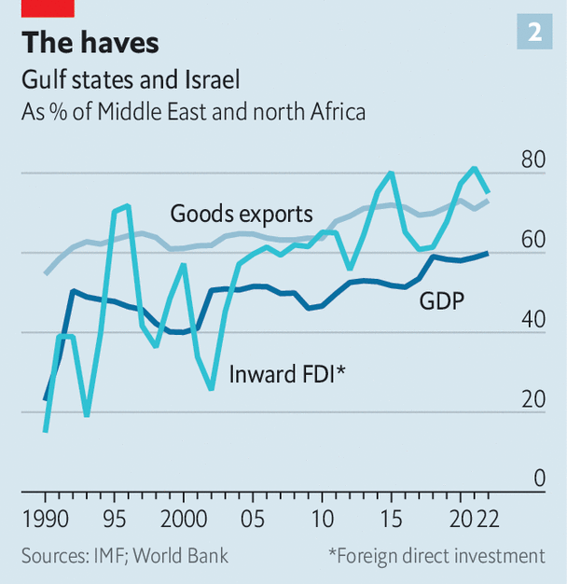

image: the economist

Another risk is that even the region’s prosperous countries will fail to create the jobs and growth they have promised. They have undeniably done better to date than their counterparts elsewhere in the Middle East. In 1975 Saudis and Libyans had roughly the same gdp per person; today the Saudi figure is 353% higher. The Gulf and Israel (the region’s other prosperous spot) account for just 14% of the Middle East’s population, but 60% of its gdp, 73% of its exports of goods and 75% of its fdi (see chart 2).

But Saudi Arabia, like its neighbours, is battling deep structural problems. Citizens still see a cushy public-sector job as a birthright. The government employs fully 53% of working Saudis, although that is down from 66% in 2019. Schools do not teach marketable skills. Wages are too high for the kingdom to become a manufacturing hub, at least without costly state subsidies.

另一个风险是即使该地区的繁荣国家也可能无法创造他们所承诺的就业和经济增长。毫无疑问，与中东其他地区相比，这些国家迄今为止的表现要好得多。1975年，沙特阿拉伯和利比亚的人均国内生产总值大致相同；而如今，沙特阿拉伯的数值比利比亚高出353%。海湾国家和以色列（该地区的其他繁荣地带）仅占中东地区人口的14%，但却贡献了该地区60%的国内生产总值、73%的货物出口和75%的外国直接投资（见图表2）。

然而，沙特阿拉伯以及其邻国都面临着深层次的结构性问题。公民们仍然将获得舒适的公共部门工作视为天赋。政府雇佣了53%的沙特劳动力，尽管这一比例已从2019年的66%下降。学校未教授具有市场价值的技能。工资水平过高，使得该国难以成为制造业中心，至少在没有昂贵的国家补贴的情况下是如此。

Prince Muhammad hopes annual foreign direct investment will be $100bn by 2030. Last year it was just $8bn. That leaves the government as the main agent of economic transformation, which is worrying in two respects. First, its finances are hostage to oil markets. Analysts estimate that the kingdom runs a deficit when the price drops below $100 a barrel, if off-budget spending by its sovereign-wealth funds is included. It is currently about $90—its highest for almost a year.

Second, it is far from clear that the government’s investments in diversification will pay off. Vision 2030, the kingdom’s economic blueprint, predicts tourism will contribute 10% of Saudi gdp by the end of the decade. Officials claim the industry will generate 1m jobs, enough to hire one in 20 Saudis, a higher share than in France or Spain. But there is scant evidence of the hoped-for flood of 100m annual visitors. Last year there were just 16m, estimates the un—about 1.5m fewer than in 2016, the year the vision was adopted.

Another worry is that the ideological arguments that leaders are so eagerly papering over will at some point resurface. Saudi Arabia is pursuing a détente with Iran even as the latter continues to produce highly enriched uranium for its rogue nuclear programme. Should the regime go further and manufacture a bomb, it could trigger a regional arms race—or even a war.

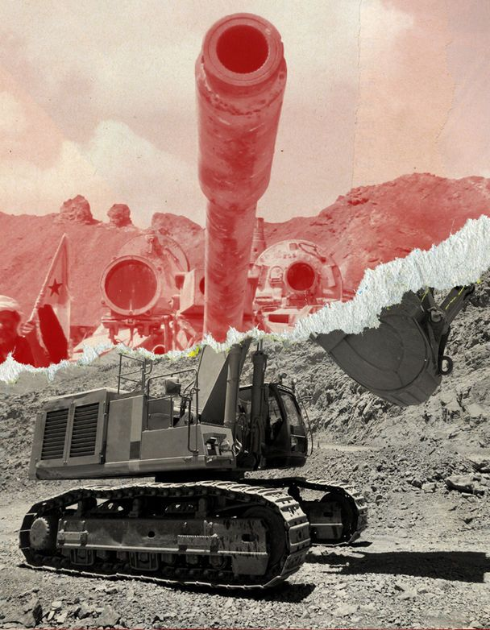

image: anthony gerace/getty images

The Israeli-Palestinian conflict has been relatively subdued for the past two decades, but it is unlikely to stay that way for ever. Serious conflict in the Holy Land could shake Arab agreements with Israel. Violence has ebbed in Libya, Syria and Yemen, but the underlying disputes remain unresolved. Mr Assad faced a wave of protests last month in Sweida, a restive southern province. And Saudi Arabia and the uae, although the main cheerleaders for the new Middle East, often disagree about both foreign policy and economic matters.

过去20年来，以色列和巴勒斯坦的冲突相对较为平息，但这种局势不太可能永久持续下去。在圣地发生严重冲突可能动摇阿拉伯国家与以色列的协议。尽管利比亚、叙利亚和也门的暴力冲突有所减弱，但根本性争端仍未解决。上个月，阿萨德在动荡不安的南部省份斯韦达面临了一波抗议浪潮。此外，尽管沙特阿拉伯和阿联酋是新中东的主要支持者，但在外交政策和经济问题上经常存在分歧。

The final risk is that the region gets its geopolitical balancing act wrong. America is still the only country willing and able to project military power across the region, and its domination of the global financial system gives it unmatched economic clout. The Gulf states cannot risk losing it as a partner. Yet their dalliances with Russia and China are prompting mounting anger in Washington. America has imposed sanctions on a few firms in the uae, including one accused of supplying drones to Russia. It has delayed a deal to sell f-35 fighter jets to the country because of allegations of a Chinese military presence at a port in Abu Dhabi.

最后一个风险是该地区对地缘政治的平衡把握不当。美国仍是唯一愿意并有能力在该地区展示军事力量的国家，其对全球金融系统的主导地位也使其拥有无与伦比的经济影响力。海湾国家不能冒险失去美国作为合作伙伴的地位。然而，它们与俄罗斯和中国的接触引发了华盛顿越来越大的不满。美国对阿联酋的一些公司实施了制裁，其中包括一家被指控向俄罗斯供应无人机的公司。由于指控中国在阿布扎比港口存在军事存在，美国推迟了向该国出售f-35战斗机的交易。

Gulf states are “planning in part their future prosperity on the assumption that China’s economic rise will continue”, notes Emile Hokayem of the International Institute for Strategic Studies, a British think-tank. There are warning lights flashing over China’s economy, though: slow growth, an ageing population, a moribund property market. A big gamble on China that alienates America could leave the Gulf in a difficult spot.

The fact is, Prince Muhammad is not the first regional leader to wax lyrical about a renaissance in the Middle East. There are many parallels between the current era and the 1990s, another time when the region seemed to be trying to put its violent past behind it. The Oslo accords appeared to herald an end to the Israeli-Palestinian conflict. Lebanon’s long civil war had sputtered to a halt. Autocrats in Egypt, Jordan and Syria talked about opening their hidebound economies. So did Abdullah bin Abdulaziz, the Saudi crown prince of the day, who promised bold reforms and sought better relations with Iran.

根据英国智库国际战略研究所的埃米尔·霍凯姆指出，海湾国家“在一定程度上将未来的繁荣建立在中国经济持续崛起的假设上”。然而，中国经济也存在一些警示信号，如增长放缓、人口老龄化以及不活跃的房地产市场。对中国进行大胆的赌注而疏远美国，可能会让海湾国家陷入困境。为避免歧义，有必要指出中国经济未来的发展仍存在一定的不确定性。

巴勒斯坦冲突。 黎巴嫩旷日持久的内战已经戛然而止。 埃及、约旦和叙利亚的独裁者谈到了开放其墨守成规的经济。 当时的沙特王储阿卜杜拉·本·阿卜杜勒阿齐兹也是如此，他承诺进行大胆的改革，并寻求与伊朗建立更好的关系。

In 1993 Shimon Peres, then Israel’s foreign minister, wrote a book called “The New Middle East” arguing that trade would pacify the region. “Ultimately, the Middle East will unite in a common market,” he stated. “And the very existence of this common market will foster vital interests in maintaining the peace over the long term.”

History, sadly, had other ideas. The Israeli-Palestinian peace process gradually ground to a halt. America invaded Iraq in 2003 and Israel sent its army into southern Lebanon in 2006. Supposedly modernising autocrats across the region proved quite bad at the modernising bit, which precipitated the Arab spring. Gulf economies stayed oily, save for Dubai, which never had much oil to begin with.

An era of peace and development is a tempting vision, but to attain it, the region’s autocrats must be serious about keeping the peace and smart about fixing their economies. The present circumstances give them a chance to change, and technological and geopolitical forces provide an incentive. The rest is up to them.

1993年，时任以色列外交部长的西蒙·佩雷斯撰写了一本名为《新中东》的书，主张贸易将促进该地区的和平。他指出：“最终，中东将团结在一个共同市场中。”“而这个共同市场的存在将培育对于长期维持和平至关重要的利益。”

可悲的是，历史却另有想法。 以色列-巴勒斯坦和平进程逐渐陷入停滞。 美国于 2003 年入侵伊拉克，以色列于 2006 年派遣军队进入黎巴嫩南部。事实证明，整个地区的现代化独裁者在现代化方面表现得相当糟糕，从而促成了阿拉伯之春。 除了迪拜以外，海湾经济体一直处于石油状态，迪拜本来就没有多少石油。

和平与发展的时代是一个诱人的愿景，但要实现这一愿景，该地区的独裁者必须认真维护和平并明智地修复经济。 当前的形势给了他们改变的机会，技术和地缘政治力量提供了激励。 剩下的就看他们的了。